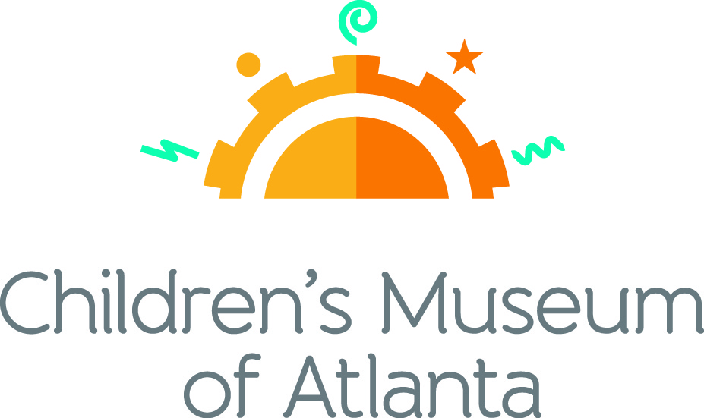

CONTACT
Alison Wentley
BRAVE PR, 404.233.3993
awentley@emailbrave.com

FOR IMMEDIATE RELEASE

Children’s Museum of Atlanta Raises $182,500
with seventh annual ‘Tournament for PLAY’
Golf fundraiser proceeds support early childhood educational exhibits
and community outreach programs
ATLANTA (August 22, 2019) – On Monday, Aug. 12, roughly 120 golfers participated in Children’s Museum of Atlanta’s seventh annual Tournament for PLAY, presented by PNC Bank and hosted at the prestigious Peachtree Golf Club. More than $182,000 was raised at the event as a result of the generous donations made by both participants and sponsors. All funds raised will directly benefit the Museum’s early childhood learning programming and community outreach initiatives.
“Tournament for Play is one of our most anticipated events every year,” said Jane Turner, executive director for Children’s Museum of Atlanta. “The support that the Museum receives from the Atlanta business community at this event helps us reach our goal to ensure that every child in metro Atlanta, regardless of socioeconomic, physical or mental barrier, is given the opportunity to experience education through the power of play.”
Donations from this event will help impact the lives of more than 200,000 children and caregivers that visit the Museum annually. Serving children, families and schools in Atlanta and throughout Georgia, the Museum has welcomed over 2.6 million visitors since opening in 2003. Since reopening in December 2015, following a massive renovation project, the Museum is further committed to serve the community as a world-class children’s museum and to continue to help ignite curiosity, imagination, problem-solving skills and a love of learning in the next generation of youth.

“This annual tournament provides a creative and engaging opportunity for Atlanta’s business leaders to invest in quality early learning outreach programs that positively impact thousands of Georgia’s children and their families every year,” said Eddie Meyers, PNC regional president, Greater Georgia. “The funds raised through this tournament will provide underserved children with access to exhibits and learning resources that will help prepare them for success in school and in life.”

In addition to a charitable round of golf, players were treated to a special breakfast presented by LexisNexis® to tee off the morning. The event concluded with a cocktail reception and awards ceremony to honor the winning teams, which included Saterbo Development Group, Novare Group and Stewart Title Guaranty Company. Other sponsors of the event included Mellow Mushroom, Arrow Exterminators, Lazlo, M South Equity Partners, Novare Group and Stewart Realty.

###

About PNC Bank:
PNC Bank, National Association, is a member of The PNC Financial Services Group, Inc. (NYSE: PNC). PNC is one of the largest diversified financial services institutions in the United States, organized around its customers and communities for strong relationships and local delivery of retail and business banking including a full range of lending products; specialized services for corporations and government entities, including corporate banking, real estate finance and asset-based lending; wealth management and asset management. For information about PNC, visit www.pnc.com.

About Children’s Museum of Atlanta
Children’s Museum of Atlanta is the only educational venue of its kind in Atlanta, presenting educational programs and exhibits designed for young children ages 0-9. The mission of Children's Museum of Atlanta is to change the world by sparking every child's imagination, sense of discovery and learning through the power of play. With six permanent learning zones consisting of bright, creative and hands-on exhibits, the Museum supports inventive play-based exploration and experiential learning focused on the whole child. Core competencies for literacy, math and science are promoted throughout all exhibits and programming in alignment with the state and national Core Performance Standards. Children’s Museum of Atlanta also offers parties, memberships, field trips, summer camp and private events. For more information or to support Children's Museum of Atlanta, visit childrensmuseumatlanta.org or call 404.659.KIDS [5437].

Museum Admission: Plan ahead and save! Families can purchase timed tickets online in advance to save money and guarantee entry to the Museum. Babies under 12 months and members are admitted for free. All daily programs are included in price of admission. Group rates and military discounts are available. For more information regarding ticket and membership options, visit childrensmuseumatlanta.org.

Museum Hours: Monday, Tuesday, Thursday and Friday 10 a.m. – 4 p.m.; Saturday and Sunday 10 a.m. – 5 p.m.; Closed on Wednesdays. Please check the Museum website to confirm hours of operation.

Facebook: facebook.com/childrensmuseumatlanta
Twitter: twitter.com/ChildMuseumATL
Instagram: instagram.com/childrensmuseumatlanta
Pinterest: pinterest.com/cmatlanta

